INTERMEDIATE (REVISION 8-20)

I - Say if the statements are TRUE or FALSE. Correct the FALSE ones –

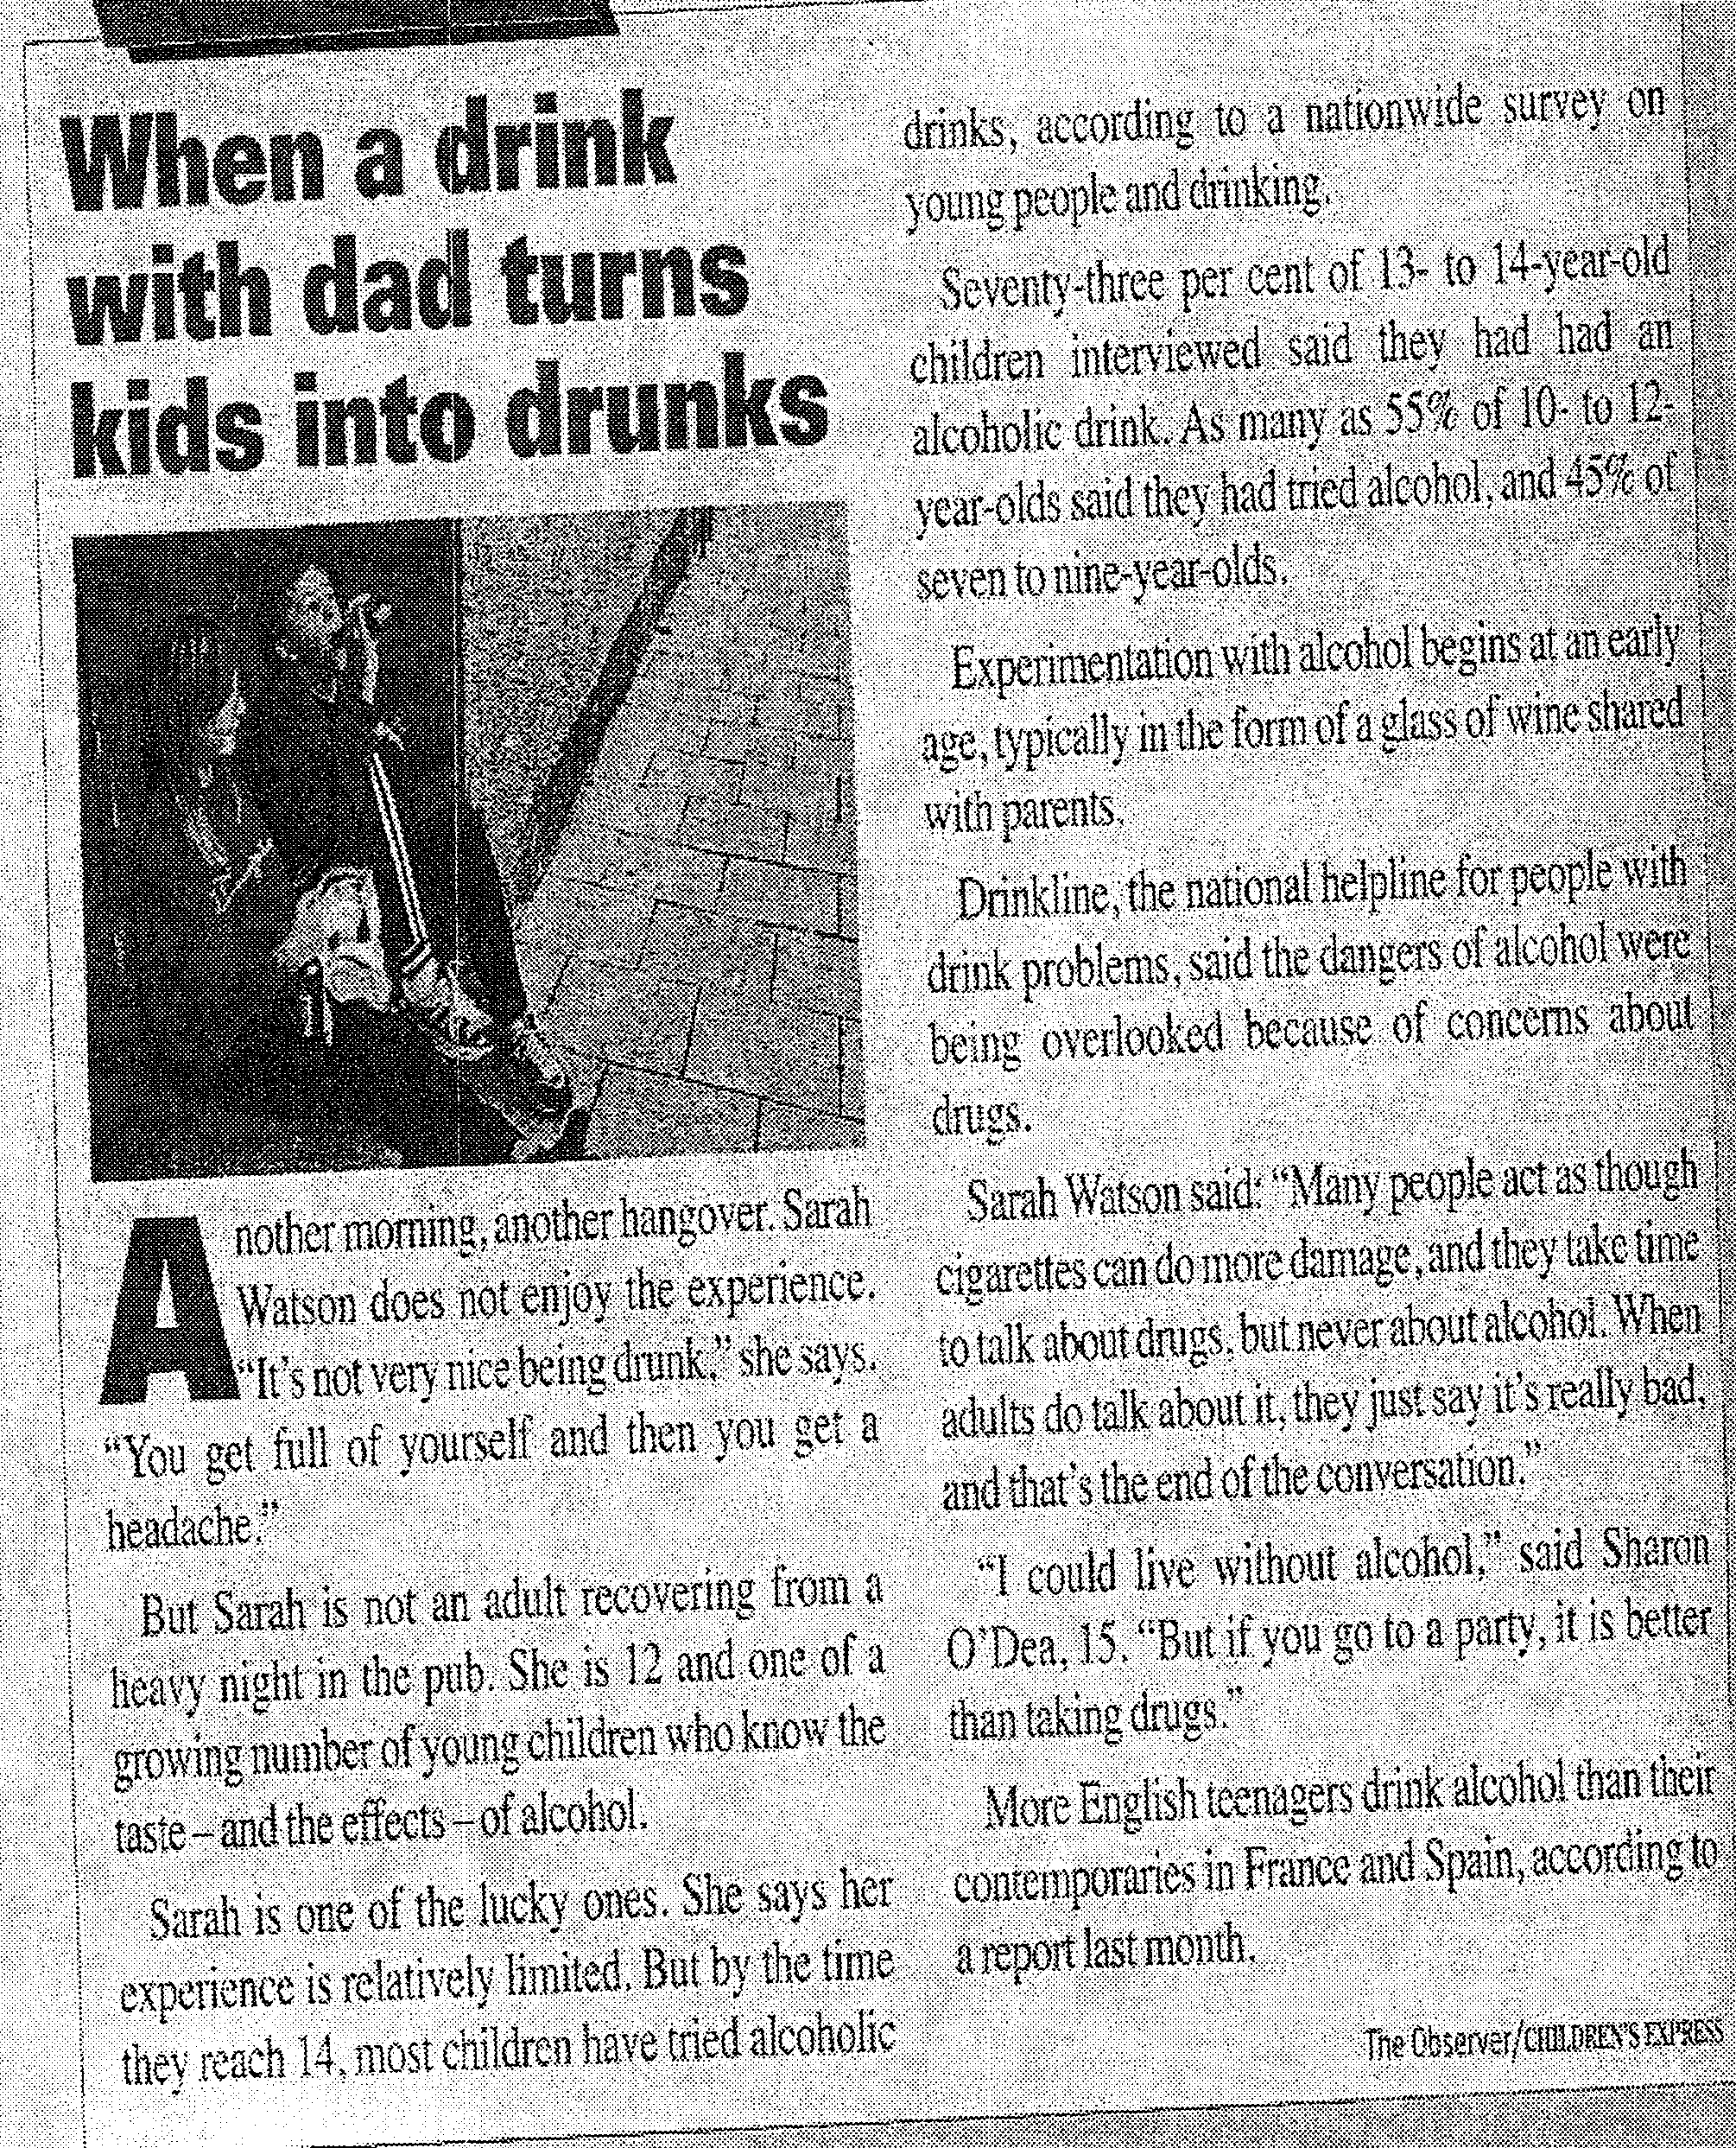
  - Sarah Watson doesn’t like drink, but she likes its effects.
  - At least 26 % of children aged 14 have never tried alcohol.
  - Less than 50 % of nine-year-olds have had an alcoholic drink.
  - According to Drinkline, everybody is now talking about alcohol problems.
  - Sharon thinks that drugs are worse than alcohol.

II – Complete with a phrasal verb –
He decided to ……………….. his own business.
You really should ……………….. smoking.
It’s very tiring to ………………. Children on your own.
I think we’ll ……………….. our credit card bills and then see what’s best to do after that.
I’ll …………… you …………… in London if you like.
Sam said all they did was argue, and he couldn’t …………………. it anymore.
There’s no need to panic. ……………………!

III –Sentence transformation, without changing the meaning –
- I ate nothing at the weekeend. DIDN’T
I .................................................................................. weekend.
- How many times have they injured you playing football? BEEN
How many times..............................................................................................?
- Paul has excellent marks, but she wasn’t accepted at university. ALTHOUGH
...................................................................................... she wasn’t accepted at university.
- Tom is very nervous, so he won’t sit for the exam. RELAXED
......................................................................................, he would sit for the exam.
- In the past people often made their own bread. USED
People ..................................................................................................................
- The director has cancelled the meeting. BEEN
The meeting .........................................................................................................
- The children organise the Christmas party every year. IS
The Christmas party .............................................................................................
- I’m thinking of going to Abbey’s birthday party, but I haven’t decided yet. MIGHT
I ....................................................................................... party, but I haven’t decided yet.
9. The smoking rooms are upstairs. ALLOWED
You ………………………………………………….…………………….
10. This is the third pet they gave him. WAS
This……………….. ……………………………………………………….
11. I didn’t know you were there. HAD KNOWN
………………………………………………………………………………
12. People stare at her when she walks down the street. IS
……………………………………………………………………………….
- The newspaper will pay her $ 50,000 compensation for the embarrassing photos. BE
………………………………………………………………………………………………

IV - Write the correct form of the verbs – 11 marks
The 22-year weekend break
David Davidson, 79, and his wife, Jean, 70, HAVE BEEN LIVING (live) in Travelodge hotels for over 22 years. The couple ……………….. (spend) more than $ 150,000 staying at the hotels even though they own a flat in Sheffield. They say it is cheaper than living in their own home.
The couple’s love of motel life began in the 1980s when they ………………. (stay) in a Travelodge on the A1 at Newark, Nottinghamshire, while visiting an elderly aunt. They enjoyed their stay so much that when the aunt ………………. (die) they decided to move in permanently. However, by 1997, they felt like a change, so they moved to a newly-built Travelodge, only 15 minutes away, and still on the A1. They ……………….. (stay) there ever since. They return to their flat once a fortnight to pick up their post.
Mr Davidson, a retired banker, says “We have everything we need here and the staff are like family now”. Mrs Davidson, who ………………… (suffer) from a bone disease for many years and now uses a wheel chair, said “Our room here is on the ground floor, so that’s good for me and we ………………… (bring) lots of framed photos with us so it feels like a home from home. Friends and family come to visit us here and we even get birthday and Christmas cards from the staff”.
The couple, who …………….. (marry) since 1953 and have a son called David, even use Travelodges when they go on holiday. “We ……………………. (just return) from three weeks in Savannah, Georgia, USA and, although the American Travelodges aren’t the same company, we still feel it is the only place to stay,” said Mr Davidson.
Travelodge’s director for the north of England, Paul Anstey, said: “We are delighted that the Davidsons ………………… (make) Travelodge their home. To recognize their loyalty, their room …………………. (name) ‘The Davidsons’ Suite’ and a plaque ………………… (put up) in their honour in Reception.”

English Test on Conditional Sentences Type 1, 2 and 3
Test your knowledge on Conditional Sentences. After submitting your answers, you will see how well you have done in the test.
Principio del formulario

Conditional Sentences Type I
Complete the Conditional Sentences Type I.
- If you (go)  out with your friends tonight, I (watch) the football match on TV.
- I (earn) a lot of money if I (get) that job.
- If she (hurry / not) , we (miss) the bus.

Conditional Sentences Type II
Complete the Conditional Sentences Type II.
- If he (try) harder, he (reach) his goals.
- I (buy) these shoes if they (fit) .
- It (surprise / not) me if he (know / not) the answer.

Conditional Sentences Type III
Complete the Conditional Sentences Type III.
- If we (listen) to the radio, we (hear) the news.
- If you (switch) on the lights, you (fall / not) over the chair.
- She (come) to our party if she (be / not) on holiday.

Conditional Sentences Type I, II or III
Complete the Conditional Sentences with the correct form (Type I, II or III).
- If I  stronger, I'd help you carry the piano.
- If we'd seen you, we .
- If we  him tomorrow, we'll say hello.
- He would have repaired the car himself if he the tools.
- If you drop the vase, it .
- If I hadn't studied, I  the exam.
- I wouldn't go to school by bus if I a driving licence.
- If she him every day, she'd be lovesick.
- I  to London if I don't get a cheap flight.
- We'd be stupid if we him about our secret.
Final del formulario

