PRACTICE 4º PRE INTERMEDIATE 11-20

A- Say if the sentences are TRUE or FALSE. Correct the FALSE ones

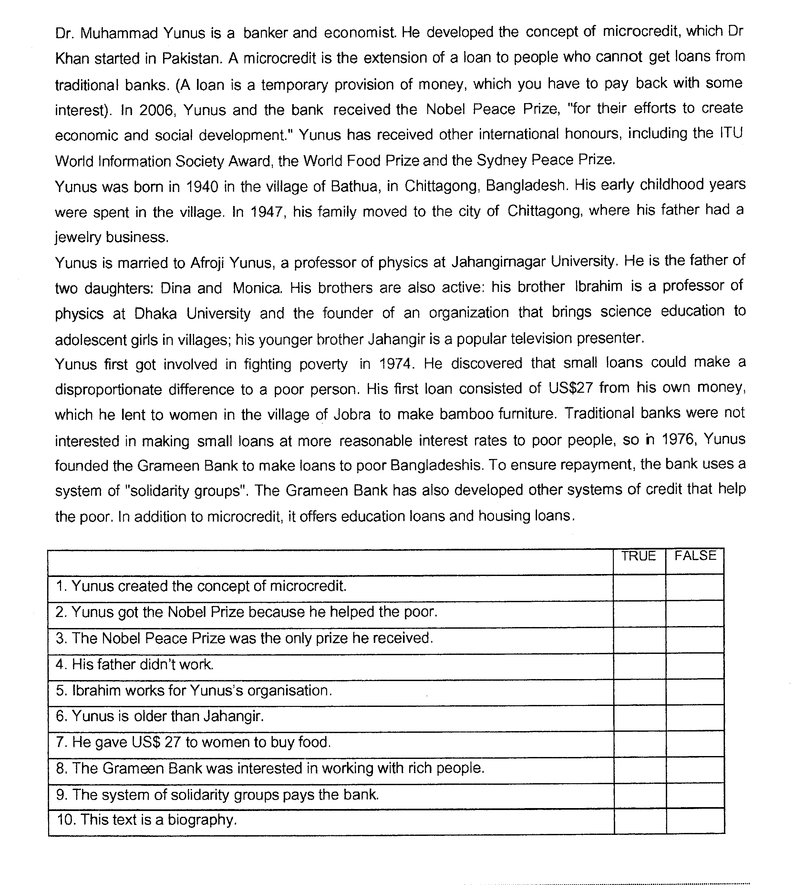

B. Linda is visiting her friend Paulo in Rio. COMPLETE THIS EMAIL TO HIS PARENTS WITH THE CORRECT TENSE OF THE VERBS IN BRACKETS
Hi mum and dad! How are you?
I hope you are just fine. When my flight (arrive) ____________ in Rio last Saturday , Paulo (wait) _________________ for me at the airport. After that we (go) _________ back to his house and he (introduce) _______________ me to his family. They are wonderful people! We (be)_____________________very busy since I arrived. Paulo (show-already)_________________me around the city but he (not-take) ______________________ me to all his favorite places yet. The weather is hot but it (rain) _______________ a little every day. Yesterday while we (drive) __________________to the farm where Paulo and his family (spend-usually) ____________________their summers, we (see) ________ a beautiful rainbow. Tomorrow, if it (not rain) ______________ we (go) _____________ to the beach. Paulo (already-buy) _____________________ tickets for the Carnival parade so tonight we (dance) ___________ samba in the Carnival festivities. I’m really excited about it. If I (be) ________ Brazilian, I (do) _______ this every year. What about you? _____ you (miss)_______ me? I hope so! Remember Paulo (get)_________________ married next Friday so I (return-probably) ______________________________ home by the end of the month. See you soon, Linda.

C. Michael and Linda are at Paulo’s wedding reception. COMPLETE THEIR CONVERSATION
Michael: nice to meet you, too. Nice party, isn’t it?
Linda: yes, lovely! Oh, you are not Brazilian. __________________________________________ ?
Michael: well…I’m originally from Washington but I live in New York now. ______________________________ there?
Linda: no, I haven’t, but I’d like to go there some day. Everybody says it’s a beautiful city. _______________________?
Michael: no, no... I grew up in Washington. I moved to New York when I started college
Laura: and tell me… where ____________________________________________________ Paulo?
Michael: well… that was in college while we ____________________________ at the UCLA. We were in the same class. And what about you? ________________________________________ here in Rio?
Linda: yes, I do. I ________________________________________________________ 5 years.
Michael: and before that? … where ______________________________________________________?
Linda: in Montreal. I ___________________________ Law at Montreal University.
Michael: and you came here when you graduated, right?
Linda: that’s right. At present I ___________________________________________ . I love my job! What about your plans after the wedding ? ________________________________________________________________________ ?
Michael: Yes, I’m going to tour this city until Monday.

D. PUT THE VERBS IN THE CORRECT TENSE, ACTIVE OR PASSIVE

Clyde Barrow’s life of crime ______________ (begin) in December 1926, when he _____________ (steal) some Christmas turkeys from a farm. He ________________ (catch) by the police, but he ______________________ (release) soon afterwards, because he was only 16 years old.
He __________________ (meet) Bonnie Parker in 1930. Together they ___________________ (rob) a great number of shops and banks.
Innocent people ____________________ (often/ kill) in these robberies.
Large rewards ________________ (offer) for their capture, and they _______________________ (chase) from State to State by hundreds of police, but they _____________(always/escape).
Eventually, in 1934, Bonnie and Clyde ________________ (catch) in a police ambush. Their car ______________________ (hit) by a hail of bullets, and they _______________________ (arrest).

E. Rewrite the sentences in the Passive
1- Someone sells new smartphones online.
2-People built Stonehenge thousands of years ago.
3-Someone has already cleaned my house.

F -Fill in the blanks with: WHILE, WHEN, BUT, BEFORE; OR, BECAUSE, UNTIL
Remember to brush your teeth …………. you go to bed.
Do what I say …………. I’ll send you to your room.
…………….. someone says ‘hello’ to you, say ‘hello’ back.
You’re laughing, ……………. It’s not funny.
You can’t have an icecream ………………. You didn’t eat your vegetables.
……………… you’re at school, I have to go out to work.
You can’t leave the table …………….. you’ve eaten what’s on your plate.

