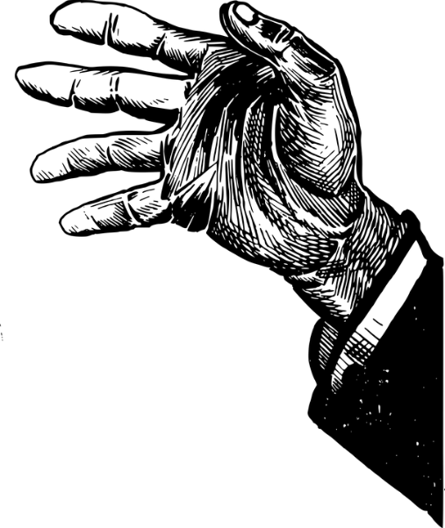
Multiple Choice

- What is the main idea of the first paragraph?
  - The car had electronically operated window and sunroof.
  - The car had a powerful engine.
  - The main character had a new BMW sports car.
  - The main character enjoyed driving.

- “The powerful engine growled and grunted impatiently at slow speeds, but at sixty miles an hour
the growling stopped and the motor began to purr with pleasure.”
To what does Roald Dahl compare the engine to in this extended metaphor?
  - a gorilla
  - a large cat
  - a centipede
  - a wild boar

- Had the driver been a hitchhiker before?
  - Yes
  - No

- What was the story teller’s occupation?
  - a race car driver
  - a writer
  - a pick-pocket
  - an investigator

- Why was the story teller traveling much faster than the speed limit?
  - He was distracted by the conversation and didn’t realize he was speeding.
  - He was trying to outrun the policeman on a motorcycle.
  - He was trying to get the hitchhiker to his destination on time.
  - He was trying to prove to the hitchhiker that his car could go 129mph.

- What did the police officer do after he returned the story teller’s driver’s license?
  - He went to the front of the car and wrote down the license plate number?
  - He asked the hitchhiker his name.
  - He checked the information was visible on the carbon copy of the ticket and gave the ticket to the story teller.
  - He filled in the time, date, and details of the driving offence on the ticket.

- "Absolutely," he said, smacking his lips. "In the clink. Behind the bars. Along with all the other
criminals who break the law.”
In context, the word “clink” means:
  - to make a toast with glassware
  - jail
  - sewer
  - to defend oneself in court

- How does a fingersmith make a living?
  - cheating at cards
  - playing the piano
  - taking valuables from unsuspecting victims
  - doing magic tricks and entertaining the public

- Race meetings is easy meat," he said. "You just stand around after the race, watchin' for the lucky ones to queue up and draw their money. And when you see someone collectin' a big bundle of notes, you simply follows after 'im and 'elps yourself. But don't get me wrong, guv'nor. I never takes nothin' from a loser. Nor from poor people neither. I only go after them as can afford it, the winners and the rich."
"That's very thoughtful of you, " I said.
The above quote best supports the conclusion that the hitchhiker
  - has a taste for the finer things in life
  - assists the needy by robbing from the wealthy
  - isn’t very daring when it comes to picking pockets
  - has a sense of honor and lives by a moral code

- Why was the hitchhiker confident nobody will be checking up on him?
  - He stole the police officer’s notebooks from his pockets.
  - He has a common name and would be easily confused with others.
  - He didn’t do anything wrong, because he was only hitchhiking.
  - He lied to the police officer about his name and address.

Short Answer

- What characteristics made the hitchhiker look like a huge human rat?

- What is the significance of the hitchhiker rolling and lighting his cigarette?

- What articles of clothing did the hitchhiker take from the story-teller?

